Recent results for St Ives and Launceston
03/11 Okehampton (H) W 27:21, 27/10 North Petherton (A) L 22:13
03/11 Cullompton (A) W 8:29, 27/10 Hornets (H) W 60:36
On Saturday after the Okehampton match, St Ives RFC proudly presented Cancer Research UK with a cheque for £2765.94. Our photo shows club Chairman, Andrew Baragwanath and Director of Rugby, Joff Rowe with local CCUK representative, Sophie Barber.
Most of the money raised came from a highly successful gala dinner held at The Tregenna Castle Hotel at the end of last season. The club has, as a part of its vision, the desire to help the wider community beyond rugby and this is one example. The funds are due to be passed on to the St Ives branch of CCUK.

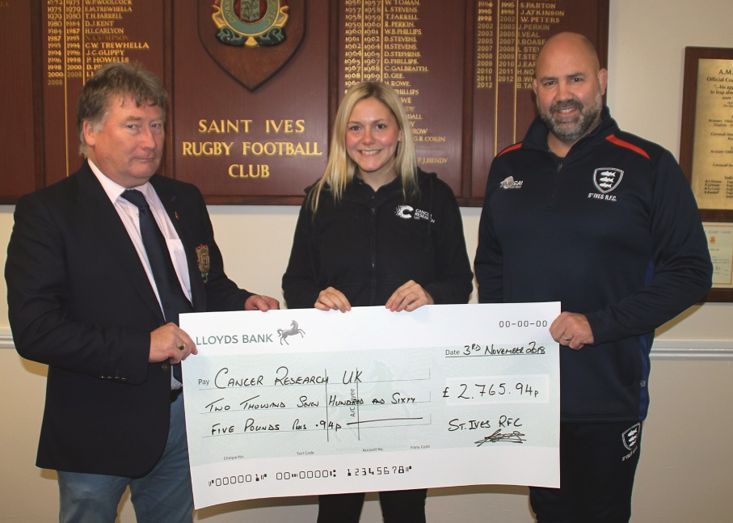
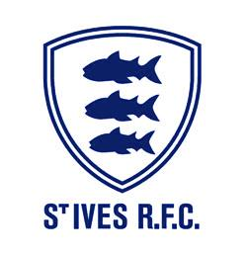 | 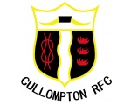

Today St Ives host league leaders, Launceston for this Cornwall Cup ‘all pay’ ¼ final. It should be a fine contest after the recent 33:40 result in favour of the visitors.
As a mark of respect to remember the fallen over the last 100 years we will hold a minute’s silence prior to kick off to reflect on their sacrifice.
Today we have an all Cornish trio of officials. Please afford them full respect. Finally, do join us in the clubhouse for refreshment afterwards.

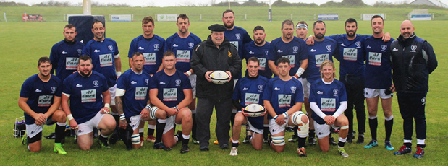

Before the match last Saturday the squad got together for a photo in front of the clubhouse under the posts with ball sponsor Bill Hooper. It is such generosity that keeps the club going and gives that extra bit of a boost for all involved to stay committed.
Alan Thomas

Other Cornwall Cup Quarter Final Fixtures Today
Penryn v St Austell | Wadebridge Camels v Truro

Next Home Fixture Next Away Fixture
Saturday 17th November Saturday 24th November
St Ives v Thornbury Teignmouth v St Ives

Follow us online:
Facebook: StIves Rfc Website: www.stivesswrfc.co.uk

St Ives Hakes v Launceston
Saturday 10th November 2018
KO 2:00p.m.
Cornwall Cup Quarter Final
at St Ives Recreation Ground

Congratulations….

St Ives girl Ebony Jefferies is delighted at being included in the England women’s U.20 rugby squad for season 2018-19. The back row forward, who has been a part of the Exeter Chiefs women’s rugby academy, is one of several Bristol Bears players to get the call.
Head coach Jo Yapp said: “Following our tour in the summer, we have seen a number of U20

Team & Player News Jack Hodge again takes a front row place on loan from Redruth. With the shortage of players in these positions The Hakes have also commandeered the services of Joli Volaisaya, also loaned from Redruth. Ben Watson comes into the 2nd Row for Jamie Hoskin. Coaches Elloway and Fuca are rested. Launceston make five changes since the last meeting five weeks ago.
players into selected the Red Roses squad ahead of the Quilter Internationals.
“This provides an opportunity for new players who have come through the pathway. This season we have seen a number of good performances at club level in the Tyrrells Premier 15s, which is proving a great platform for player development.
“We are now looking forward to building towards the three games later in the season.”
Congratulations to Ebony from club, committee and community. Well done indeed.

​​

St Ives Hakes |  | v | Launceston
Jack Hodge |  | 1 | Rikki Bentham
Ben Taylor |  | 2 | Levent Bulut
Ben Jenkins |  | 3 | Andy Knight
Jamie Prisk |  | 4 | Marc Williams
Ben Watson |  | 5 | Torin Clarke
Chris Quick |  | 6 | Sam Snell
Aden Brassington |  | 7 | Lloyd Duke (Capt.)
Martyn Lawrance |  | 8 | Brandon Rowley
Liam Jolly |  | 9 | Adam Collings
Rhys Brownfield |  | 10 | Glenn Coles
Jack Kessell |  | 11 | Ben Hawke
Grant Thirlby |  | 12 | Tom Sandercock
Tom Nicholas (Capt.) |  | 13 | Ryan Westren
Joe Parma |  | 14 | Daniel Pearce
Dan Magee |  | 15 | Reuben Edwards
Replacements
Peter Mabbott |  | 16 | Chae Jenkins |  | 16
Joli Volaisaya |  | 17 | Jordan Duke
Connor Bick |  | 18 | Harry Lightfoot
 |  | 19 | Shaun Crawford
Referee: Ian Pengelly (CRRS)
Kevin Williams | Assistant Referees |  |  | Rob Lowe

