Current League positions
 |  | P | W | D | L | F | A | D | Pts | Adj
10 | Okehampton | 22 | 8 | 1 | 13 | 470 | 554 | -84 | 43 | 9
11 | Bude | 23 | 7 | 0 | 16 | 333 | 675 | -342 | 33 | 5
12 | Tavistock | 22 | 5 | 2 | 15 | 446 | 733 | -287 | 33 | 9
13 | St Ives | 22 | 5 | 1 | 16 | 388 | 576 | -188 | 29 | 7

St Ives v Okehampton

Saturday 29th March 2014
KO 3:00 p.m.
at
St Ives Recreation Ground
Today we welcome Okehampton to The Recreation Ground at Alexandra Road as St Ives face a massive relegation struggle in the closing stages of this season’s Tribute Western Counties West league. While we may all feel St Ives are ‘too good to go down’, the reality of the league table following Bude’s defeat of Torquay Athletic last Saturday, means that Rob Elloway and Tom Riley’s squad need results. A win today is crucial. This has to be the response to our game in hand over Bude, even though they have a difficult set of fixtures in front of them to conclude their season.
After six straight loses, The Okes have rallied to gain two recent victories to push themselves just outside the relegation zone. They will want to bounce back from a 69:0 defeat at Ivybridge in their last match on 15th March. St Ives might have hoped for better at Wellington last week going down 37:8. The Hakes have this opportunity to get a win in March; having suffered four loses to date. The coaches have selected a strong squad with few injury problems. Only the much improved Tom Chandler is missing.
I will leave you with the fixture lists for each of the clubs involved and you can consider the various outcomes.
Day & Date |  | St Ives |  | Tavistock |  | Bude
Sat | Mar 29th | Okehampton | H | Wellington | H | Truro | A
Sat | April 5th | Paignton | A | Okehampton | A | Kingsbridge | H
Sat | April 12th | Penryn | H | Paignton | H | Burnham | A
Mon | April 21st | Kingsbridge | A
Sat | April 26th |  |  | Kingsbridge | H
We welcome our match official for today’s game, Mr Ian Paddock of Bristol Rugby Referees Society and trust he, the players, officials and spectators all enjoy an excellent game of rugby.
Alan Thomas

Today’s Tribute Western Counties West League fixtures
Results:  Saturday 22nd March  Wellington 37:8 St Ives | Fixtures:  Next fixture:  Saturday 5th April  Paignton Saxons v St Ives  Last home fixture:  Saturday 12th April  St Ives v Penryn
“LAST OF THE SUMMER WINE”
END OF SEASON BUFFET - SATURDAY 12TH APRIL 2014
The “Last of the Summer Wine” buffet will be held in the clubhouse on Saturday 12th April, 13.00-15.00, before the St Ives v Penryn game. Tickets, £10.00 per person; details can be obtained from
Mr. Danny Perkin, Club President. This is the last home game of the season and your support at this event would be greatly appreciated...
Kingsbridge |  |  | Burnham-on-Sea
Penryn |  |  | Paignton Saxons
St Ives (SW) |  |  | Okehampton
Tavistock |  |  | Wellington
Teignmouth |  |  | Ivybridge
Torquay Athletic |  |  | Devonport Services
Truro |  |  | Bude

ST IVES RFC DINNER DANCE FRIDAY 25TH APRIL 2014
The Club Dinner Dance will be held at the Carbis Bay Hotel from 18.30-01.00. Details are available on the club notice board in the main hall. The Carbis Bay Hotel has generously agreed to support the club by reducing the cost of the meal from £25.00 per head to £21.00 per head. The hotel has also kindly agreed to support the evening by offering vouchers as raffle prizes for Sunday Lunch or Spa treatments in their new Carbis Bay Spa. St Ives RFC wishes to thank Mr Stephen Baker, Managing Director of the Carbis Bay Hotel, for his generosity and support of St Ives RFC.

ST IVES RFC MEMBERS DRAW/200 CLUB DRAW
There will be 2 draws today. The members draw for £30.00. There will also be a draw for 2 free tickets for the Dinner/Dance and Presentation evening. To win any of the Member's Prizes all you have to do is be in the bar with your membership card when the draw is made. The 200 Club draw for March will be made by 200 Club Members before 18.00. Winners will be notified in the usual way.

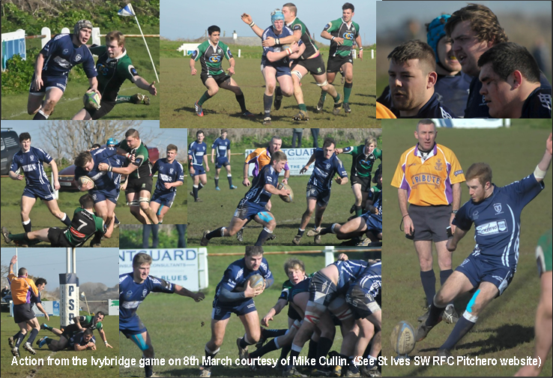

St Ives ‘Hakes’ | V | Okehampton ‘Okes’
Tyler Gendall | 1 | Nick Martin
Ben Taylor (Capt) | 2 | George Trerise
Ben Jenkins | 3 | Ian Langbridge
Todd Prisk | 4 | Nathan Abrams
Jamie Prisk | 5 | Jack Barkwell
Sam Heath | 6 | Dean Abrams
Ellis Cox | 7 | Paul Lawrence
Neil Corin | 8 | Tom McGrattan
Treve Polglase | 9 | Joe Bruce
Kelvin James | 10 | Gareth Espin
Jacob Ninnes | 11 | Matt Dennis
Josh Semmens | 12 | Tom Powell
Ben Drew | 13 | Deane Andrew
Jack Lonsdale | 14 | Robert Fishleigh
Jack Kesssell | 15 | Gary Sizmur
Replacements
Liam Trudgeon | 16 | Steve Gove
Neil Stanleick | 17 | Mark Gibbs
Kieran Harvey | 18 | Ian Perrott
Referee: Mr Ian Paddock (Bristol RRS)

