St Ives v Chard

Saturday 25th November 2017
KO 2:30 p.m.
at
St Ives Recreation Ground
Today we welcome Chard to The Recreation Ground for this latest Tribute Western Counties West league match. We hope you have an enjoyable and entertaining afternoon.
Chard is the only club from Somerset in this league. This will be their furthest trip of the season. Their location means that the league they play in depends, to a degree, on which other clubs are relegated or promoted. They have enjoyed their highest league status in recent years, with a spell in South West One West and a season in National league 3 South West. Prior to this they were in the Somerset leagues. So paths have not crossed, certainly in recent history. Others may have better memories than me.
Of five wins this autumn, Chard have captured only one victim away from home; Burnham on Sea back in early September. Coach, Mark Wesemann will be hoping for a change of fortune.
St Ives will be fully intent on preserving 2nd place after a win on the road last week. A long trip to Crediton is followed by the last home match of the year, against Devonport, which could prove vital.
The match referee today is Al Denham. We remind all spectators to afford our officials respect and appreciate their efforts in the cause of rugby.
Please join us in the club house after the match for a drink and a chat.
Alan Thomas

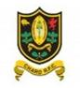
Squad Sponsors
This season at Alexandra Road, we are delighted to have sponsors for our forwards and backs. Between them they have all given many years to the club as players and now continue to do so as supporters.

Forwards
Peter Hendy
Polpeor Café
(The Lizard)
Andrew Skinner
Renewable Energy Consultancy
(New Zealand)
Backs
Stuart Turnbull & Mike Phillips
Aventail Security
Bradley Gibson
Camborne Joinery
Next league fixture:  Saturday 2nd December  Crediton v St Ives |  |  | Next home league fixture:  Saturday 9th December  St Ives v Devonport Services

League positions 2017-2018
 |  | P | W | D | L | F | A | D | Bon | Pts
2nd | St Ives | 10 | 8 | 0 | 2 | 275 | 184 | 86 | 7 | 39
6th | Chard | 10 | 5 | 1 | 4 | 177 | 178 | -1 | 5 | 27

St Ives ‘Hakes’ | V | Chard  Today’s fixtures in the Tribute Western Counties West League  Paignton Crediton  Sidmouth Devonport Services  St Austell Falmouth  St Ives (SW) Chard  Tiverton Burnham-on-Sea  Torquay Athletic Truro  Wadebridge Camels Kingsbridge  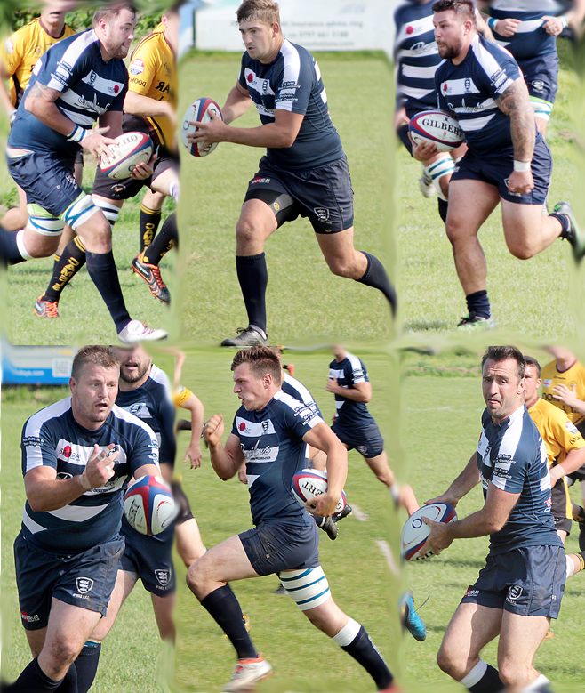
Ben Taylor | 1 | N.Hyslop
Rob Elloway | 2 | J Mainwaring
Leigh Hocking | 3 | Liam Mustchin
Ben Jenkins | 4 | W Lewis
Jamie Prisk | 5 | S Johnson
Harry Parton | 6 | D Biss
Chris Quick | 7 | J Wright
Martyn Lawrance | 8 | M Gosden
Sam Carter | 9 | D Moss
Rhys Brownfield | 10 | B Twigg
Peter Mabbott | 11 | R Colenso
Matt Holland | 12 | W Biss
Tom Nicholas | 13 | N Tinley
Josh Palmer | 14 | E Syzedko
Jacob Ninnis | 15 | C Roberts
Replacements
Kye Beasley | 16 | L Hill
Grant Thirlby | 17 | D Richards
Matthew Nichol | 18 | J Wagstaff
Referee: Al Denham (CRRS)
Debutant: Members will notice a new name on the team sheet. Chris Quick makes his debut for the club in the back row.

