League positions
 |  | P | W | D | L | F | A | D | Pts
5 | Torquay Athletic | 4 | 3 | 0 | 1 | 105 | 83 | 22 | 13
14 | St Ives | 4 | 0 | 0 | 4 | 51 | 141 | -90 | 0
Today’s Tribute Western Counties West League fixtures

Ivybridge |  |  | Burnham-on-Sea
Okehampton |  |  | Bude
Paignton Saxons |  |  | Kingsbridge
Penryn |  |  | Truro
St Ives (SW) |  |  | Torquay Athletic
Tavistock |  |  | Teignmouth
Wellington |  |  | Devonport Services

St Ives v Torquay Athletic

Saturday 5th October 2013
KO 3:00 p.m.
at
St Ives Recreation Ground

We extend a warm welcome to regular visitors, Torquay Athletic RFC, for today’s home fixture in the latest round of the Western Counties West league fixtures. Torquay arrive fresh from a victory against Penryn, and will no doubt be approaching this game with optimism and confidence. St. Ives, still looking for that first elusive win, are finding life in this league to be difficult. Lack of availability is a familiar problem with teams that are struggling to find form. All stakeholders hope that the not inconsiderable effort being displayed on the field will yield some success today.
Some of you may remember a very enjoyable players’ reunion on February 25th 2012. St. Ives entertained Torquay Athletic on that day. The photo shows action from that match.
Today will see the reinstatement of having two junior mascots for each match drawn from the mini/junior section, with James Marsden and Toby Baragwanath fulfilling the role.
A reserve fixture is arranged for a combined St. Ives & Hayle team to play Penryn today with a 3:00p.m. kick off at Hayle RFC. I
Finally, we welcome our match referee, Mr. XXXXXXX and trust he will contribute to an entertaining game of rugby.

Alan Thomas

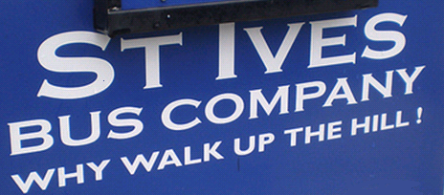
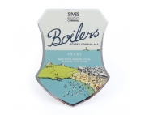
Next fixtures:

Saturday 12th October 2013
Truro v St Ives

Next home fixture:

Saturday 19th October 2013
St Ives v Kingsbridge

Action from a previous
match against Torquay.
Who are they?

Reminder:

Today, Saturday 5th October, is the last day for members to complete and hand in to Phil Allen RBS 6 Nations ticket applications.
Tower of strength, Neil Corin, with an average of one try in each of his 11 appearances, is setting high standards as leading try scorer among the forwards

St Ives
Torquay Athletic

v
Aaron Bennett
Ben Taylor (Capt)
Ben Jenkins
Tom Chandler
Todd Prisk
Sam Heath
Sean Stevens
Neil Corin
Jack Lonsdale
Jamie Prisk
Kieran Harvey
Josh Semmens
Rob Rowe
Aaron Rowe
Jacob Ninnes
1
2
3
4
5
6
7
8
9
10
11
12
13
14
15

Replacements
16
17
18
Tyler Gendall
Neil Stanleick
Treve Polglase

Referee: (CRRS)
Rugby aside (for one moment), your programme writer’s son, Matthew, will be married to Rachel (ne Duncan), within the last hour or so, if you are reading this as you wait for the kick off. Their reception is taking place in the main room of the clubhouse. Therefore, the other bar will be open today for those wishing to have a drink and social before and after the match.
The ‘other’ bar is now officially known as The Members’ Bar. It will be open every Friday. With Sky BT installed The Rugby Premiership matches will be screened. There will also be various raffles, meat draws and drinks promotions. Please make every effort to support your club and use the facilities on offer.

To launch the Friday nights at the club there will be a quiz night on Friday 11th October. Teams may have a maximum of six people, with an entry fee of £5.00 per team. This is a social evening to raise funds for Help for Heroes.
There will be a collection during the match today on behalf of Macmillan Cancer Care & Support. Please give generously.

Pete McNeil
&
Tony Rignall
St Ives MOT
Test Centre
Unit 3a
Penbeagle
Cornwall Drinks Group
Harwood Lane & Co
Chartered accountants
David Cox FCA
Tel. 01454 772727
www.harwoodlane.co.uk
Roger Corin & Co
Construction Ltd

