Form Guide (League matches)
1 | St Ives | W | W | W | W | W | W | W | 100%
14 | Plymouth Barbarians | L | D | L | L | L | L | L | 7.1%
Tribute Cornwall & Devon RFU League Table
# | Team | Pd | W | D | L | F | A | Diff | 4T | LB | Pts
1 | St Ives (SW) | 15 | 15 | 0 | 0 | 619 | 146 | 473 | 9 | 0 | 66
2 | Teignmouth | 14 | 13 | 0 | 1 | 554 | 171 | 383 | 12 | 0 | 64
3 | Tiverton | 15 | 11 | 1 | 3 | 352 | 240 | 112 | 7 | 0 | 53
4 | Saltash | 13 | 10 | 0 | 3 | 401 | 223 | 178 | 7 | 1 | 48
5 | Withycombe | 15 | 10 | 0 | 5 | 388 | 277 | 111 | 6 | 0 | 46
6 | Hayle | 15 | 7 | 2 | 6 | 291 | 324 | -33 | 4 | 2 | 37
7 | Pirates Amateurs | 15 | 6 | 1 | 8 | 266 | 309 | -43 | 4 | 2 | 32
8 | Old PMs Mannamedian | 14 | 6 | 0 | 8 | 372 | 351 | 21 | 5 | 1 | 30
9 | Falmouth | 15 | 5 | 1 | 9 | 286 | 418 | -132 | 4 | 1 | 28
10 | Newquay Hornets | 15 | 5 | 0 | 10 | 386 | 371 | 15 | 6 | 2 | 24
11 | Crediton | 15 | 4 | 3 | 8 | 197 | 286 | -89 | 0 | 2 | 24
12 | Liskeard-Looe | 14 | 3 | 1 | 10 | 203 | 402 | -199 | 2 | 1 | 13
13 | Plymouth Barbarians | 14 | 1 | 1 | 12 | 92 | 467 | -375 | 0 | 4 | 10
14 | Wessex | 15 | 1 | 0 | 14 | 131 | 553 | -422 | 2 | 2 | 8
St Ives v Plymouth Barbarians

Saturday 12th January 2013
KO 2:30 p.m.
at
St Ives Recreation Ground
In our last home fixture against Hayle, players and supporters were brought back to reality as the young, much improved and determined Lions side took St Ives to the brink of defeat. A bonus point was dropped and all were grateful for the win. True it was a sea of mud, which is ‘the great leveller’, but there can be no complacency about promotion. The 7-7 draw at Hayle on Boxing Day underlines this. The second half of the season began with a hard earned victory last week against Pirates Amateurs. The home side had taken the lead before St Ives put the game out of sight with two push over tries late in the second half. Again no bonus point, but enforced changes to the side through injury and unavailability would partly account for the lack of cohesiveness. Captain and coach will be demanding improved discipline on the field.
We warmly welcome Jane Pizii as our match official today and ask, as always, that full respect is given from the touch line.
Today sees the return of some key members of the squad as we welcome Plymouth Barbarians to a much recovered, but still soft pitch. We are all desperate to see some flowing rugby, but patience and encouragement are the virtues required by spectators today. Our opposition were formerly known as Plymouth Civil Service, founded in 1928. They were promoted from Devon One League in 2011. With some postponements last week, St Ives head up the Tribute Devon & Cornwall RFU league table. Well done to all concerned.
Alan Thomas

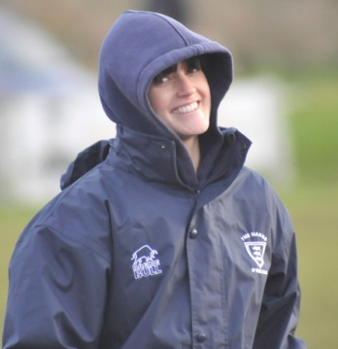
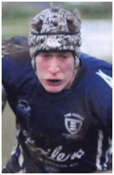
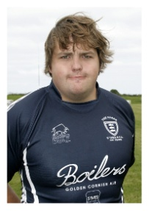
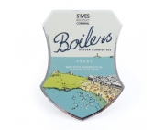
Jo Cox, the team physiotherapist, during the game against OPMs. Given the awful conditions in recent matches, Jo has to be congratulated at smiling for the camera. Thanks for all your hard work Jo. Photo: courtesy of
Mike Cullin.
Next Fixtures for St Ives teams

Today: Saturday 12th January 2013
Camborne 3rdXV v St Ives Reserves
St Ives Colts v St Austell Colts L

Saturday 19th January 2013
Saltash v St Ives 1stXV (A) L
Pirates Amateurs 2ndXV v Reserves (A)
Redruth Colts v St Ives Colts (A) L

Saturday 26th January 2013
Withycombe v St Ives 1stXV (A) L
St Ives Reserves v Falmouth Reserves
Camborne Colts v St Ives Colts L

Reminder:
Full match reports for 1stXV fixtures can be found on the club website at http://www.pitchero.com/clubs/stivessw

Tower of strength, Neil Corin, with an average of one try in each of his 11 appearances, is setting high standards as leading try scorer among the forwards

Congratulations to Tyler Gendall and Max Bodilly for their selection in the Exeter Chiefs Academy squad to play Bristol tomorrow. The club also wish a quick recovery to Todd Prisk who would have been in the squad but is recovering from a damaged hand.
Former St Ives full back Kyle Moyle, who signed for the Cornish Pirates, made his debut recently in the British and Irish cup at Swansea. Congratulations to Kyle and we wish him the very best in his new challenge.
Congratulations to Rob Elloway our senior forwards coach at the club for his recent victories in the Championship for the Cornish Pirates with wins away to Plymouth Albion on Boxing Day and home to Bristol on New Year's Day.

Player profile (backs): Jacob Ninnes 14 App, 12 Tries
Age: 18 Weight: 89kgs (14st) Height 178cms (5’10”)
Honours: Cornwall U.16’s, U17’s, U.18’s and U.20’s. Memorable moments: Winning the colts’ cup final against Launceston at Hayle in 2011; also making full home debut against Wellington last season. Favourite food: Chinese.

Player Profile (forwards): Ben Jenkins17App, 1 Try.
Age: 22 Weight 120kgs (18st 12lbs) Height: 188cms (6’2”)
Position: Loose Head Prop. Previous Clubs: Redruth Colts & Redruth 1st XV. Honours: Cornwall U.16’s, U17’s, U.18’s, U.20’s, Seniors and the South West. Memorable moment: Playing at Franklin’s Gardens
for Redruth Colts Favourite food: Anything.
Hayle 7-7 St Ives
Pirates Amateurs 11 - 24St Ives
Withycombe 37 -0 Plymouth Barbarians
Plymouth Barbarians P-P Saltash
ST IVES
PLYMOUTH B

v

1
2
3
4
5
6
7
8
9
10
11
12
13
14
15

Replacements
16
17
18

Referee: Jane Pizii (CRRS)
Recent results
Pete McNeil
&
Tony Rignall
St Ives MOT
Test Centre
Unit 3a
Penbeagle
Cornwall Drinks Group
Harwood Lane & Co
Chartered accountants
David Cox FCA
Tel. 01454 772727
www.harwoodlane.co.uk
Roger Corin & Co
Construction Ltd

